Elec 459 Lab 1  
Applications of DFT in Signal Detection and Interpolation

# Jared Mann (V00187636), Nolan Meske (V00862891)

# January 24th, 2017

# Section: B01

# T.A.: Ioana Sevcenco

### Objectives and Introduction

For this experiment, two applications of the Discrete Fourier Transform (DFT) will be explored: (1) suppression of noise in a contaminated discrete-time signal, and (2) interpolating a discrete-time signal.

### Results

#### Application 1: Signal Detection

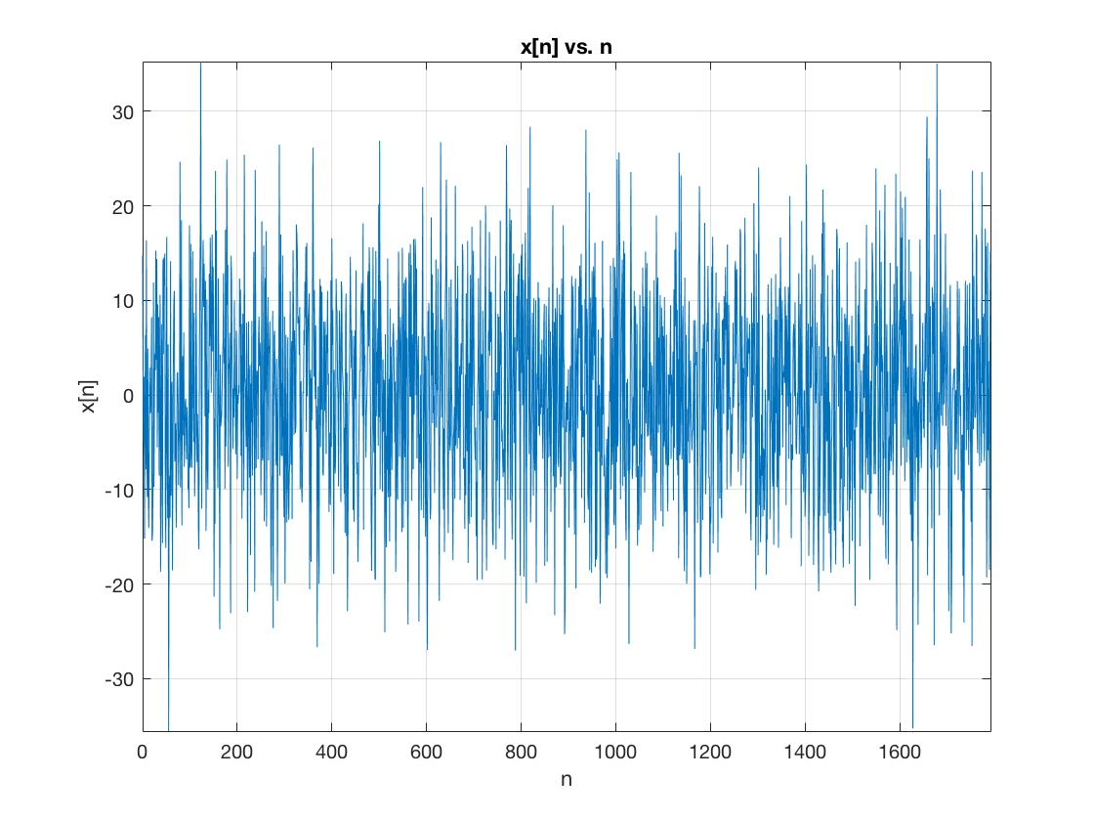

Figure : Time domain plot of .

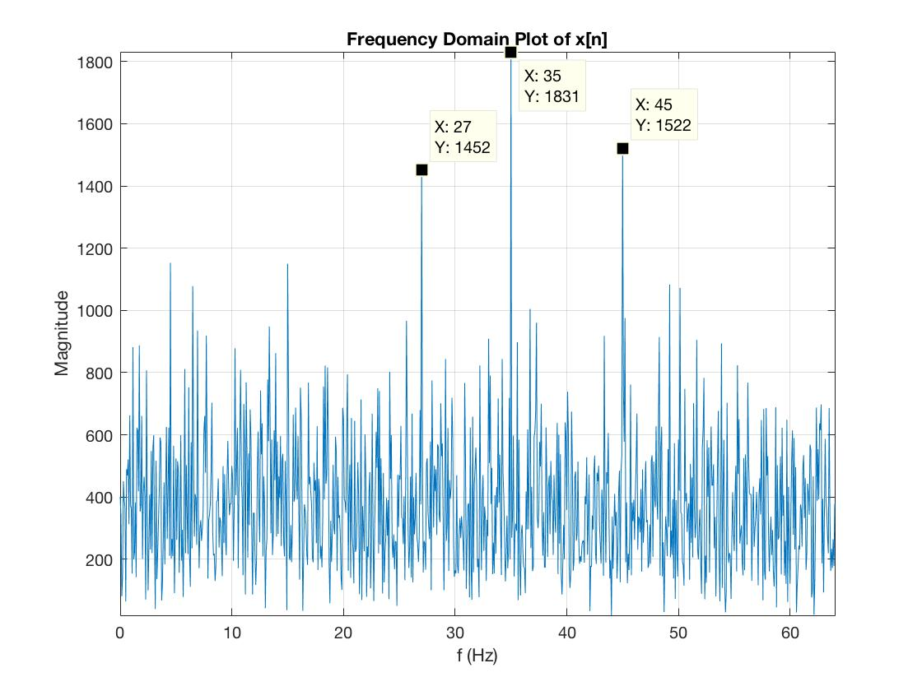

Figure : DFT plot of .

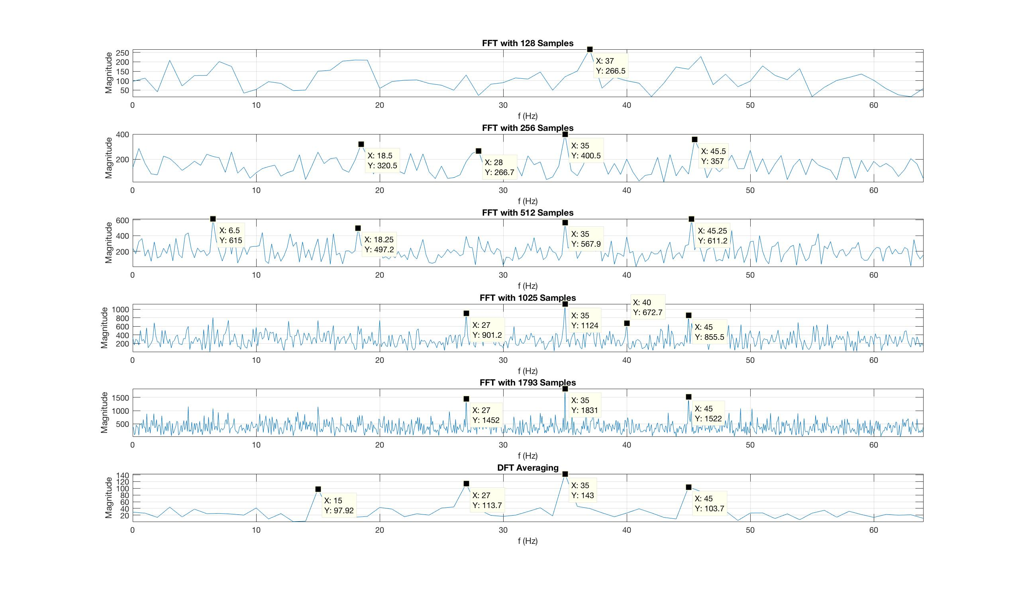

Figure : DFT of with a variety of sample ranges, as well as DFT averaging as describe in section 2.2.2 of lab manual.

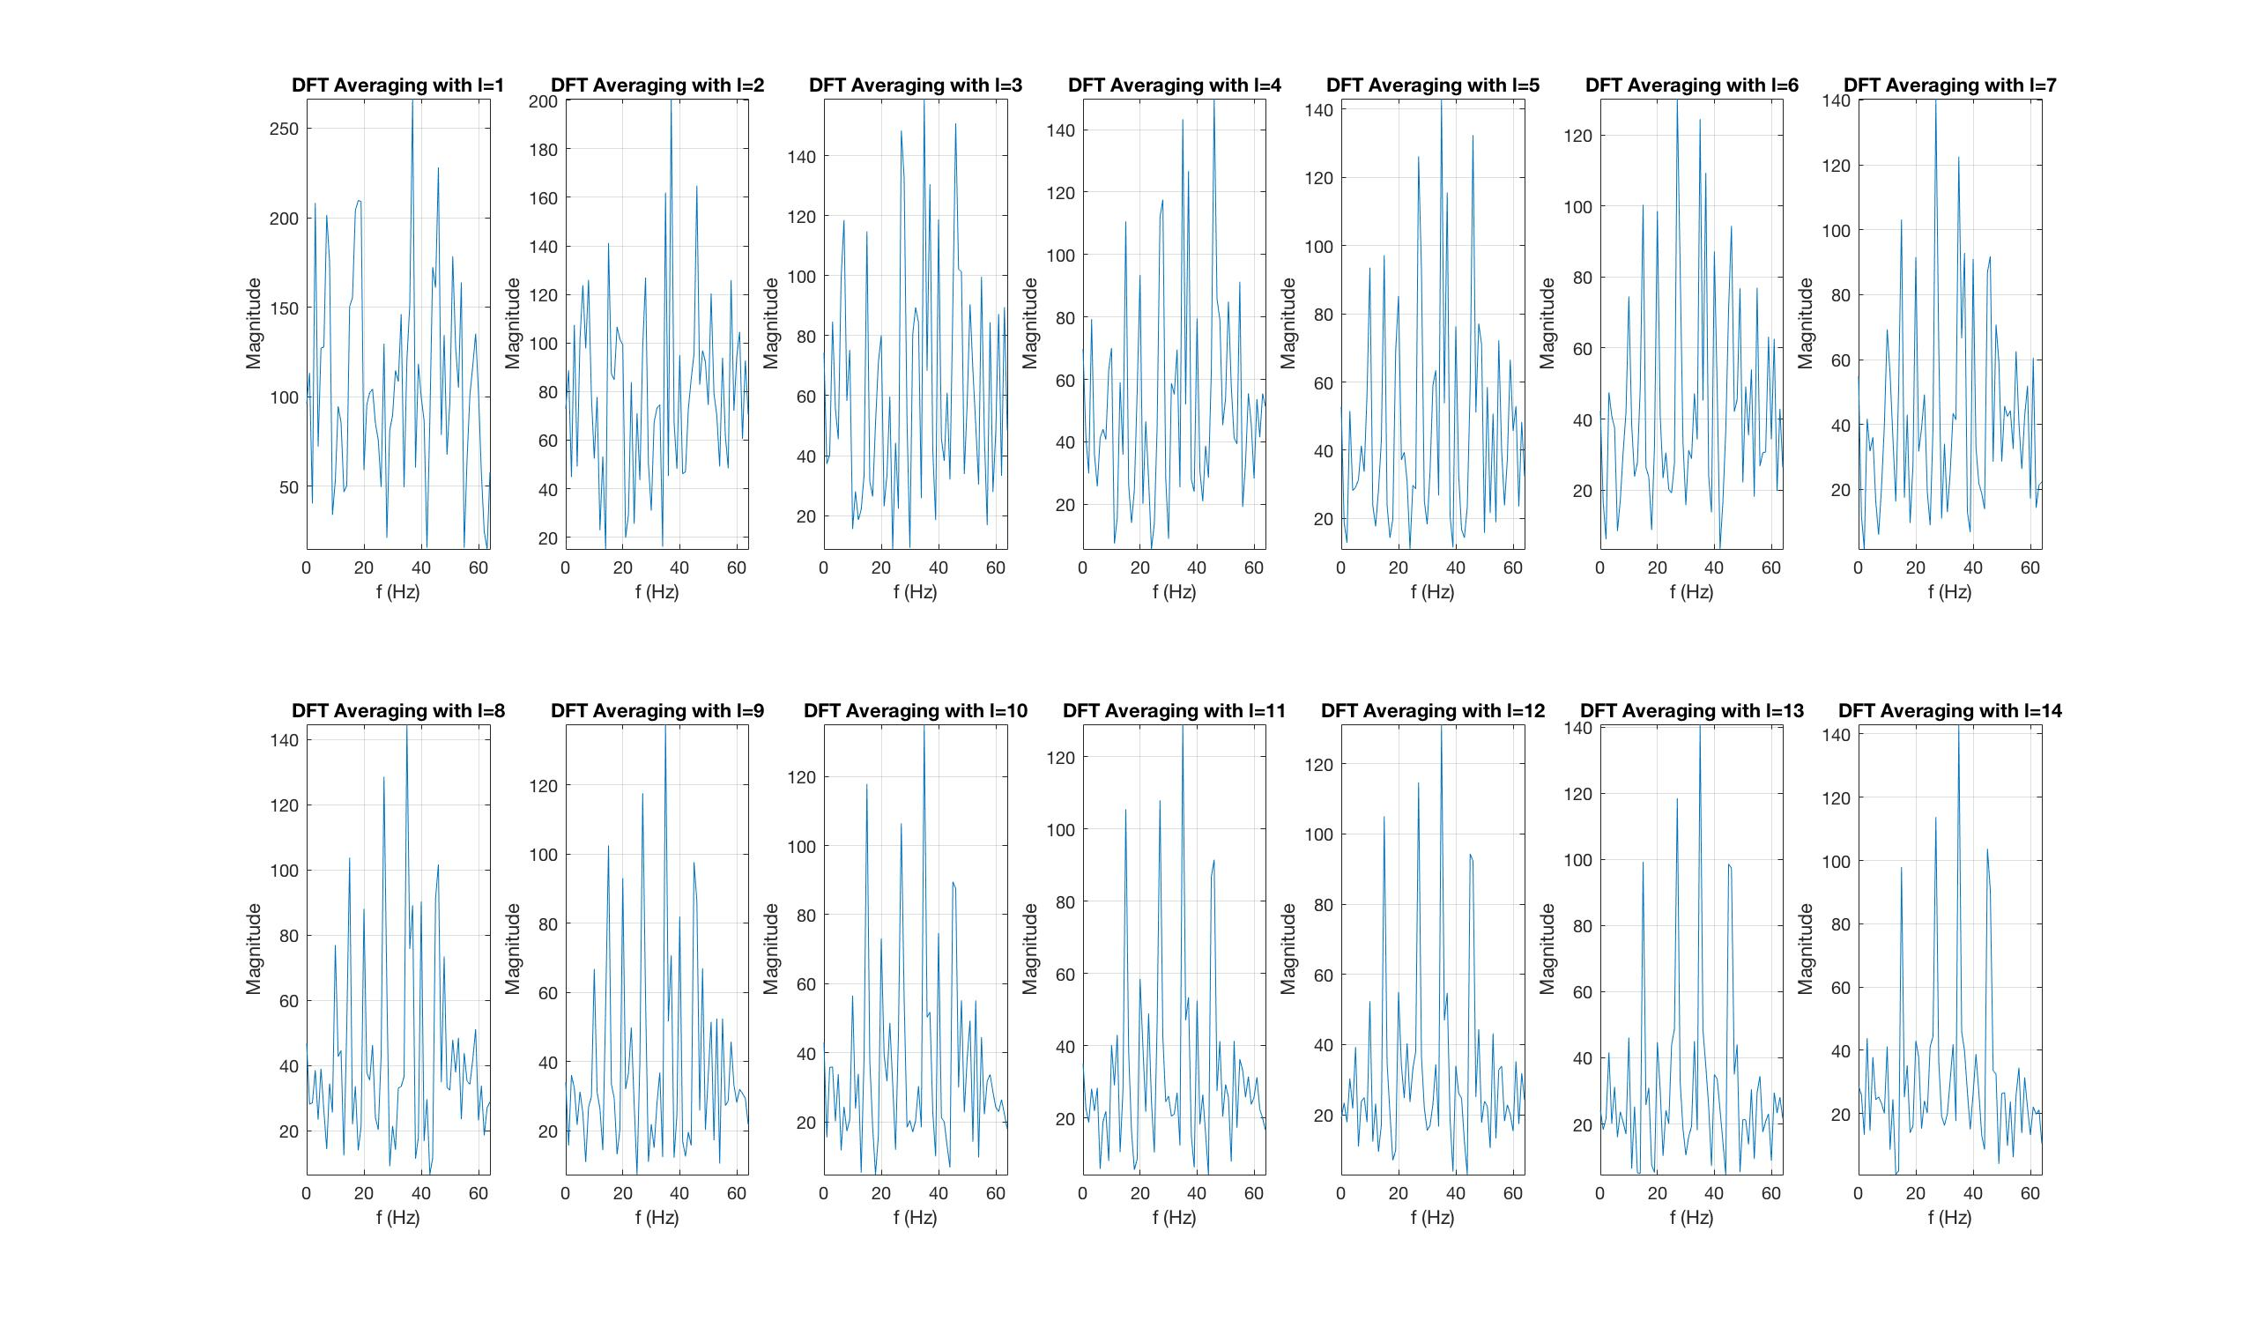

Figure : DFT plots of with various I values.

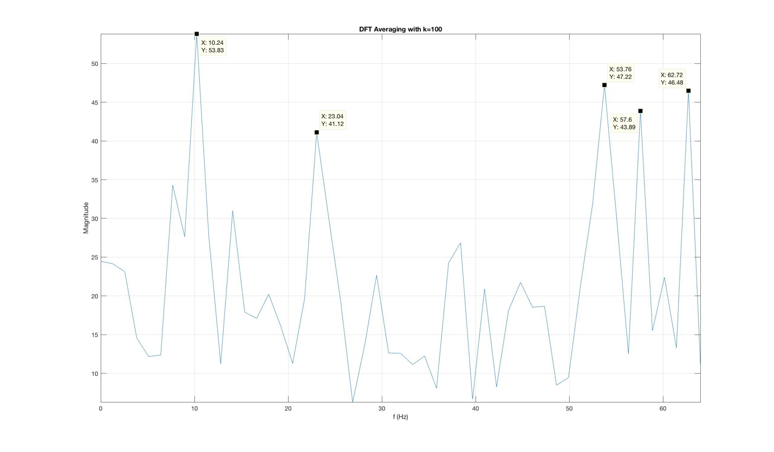

Figure : DFT with k = 100.

#### Application 2: Signal Interpolation



Figure 6



Figure 7 - 2.4.6 b



Figure 8 - 2.4.6.c Plot

### Discussion

#### Application 1

Obviously, the preferred method of determining the frequency content of the signal is to view the signal’s spectrum revealed by calculating and plotting the Discrete Fourier Transform (DFT), since the discrete-time domain plot will reveal little information about the signal’s frequency content.

The spectrum pictured in Figure 1 shows the frequency content of the noisy input signal, and it reveals harmonics at approximately 27, 35, and 45 . By taking several subsets of with an increasing number of samples, the frequency content of the spectrum became clearer and more accurate.

By implementing the DFT averaging method described in section 2.2.2 of the manual, the noise content of the signal was suppressed, and **the harmonics of the signal were revealed to be approximately 15, 27, 35, and 45 .**

Modulating the value of l reveals that the DFT averaging method can still produce relatively accurate spectrums down to .

Decreasing the value of k to say 100, decreases the number of samples used to calculate the DFT, and decreases the accuracy of the output spectrum, as observed in Figure 5. Any decrease of k, without adjusting the value of l will have the same effect. Increasing k, without adjusting l, requires a larger sample set to process, or interpolation of the samples beyond the end of the sample set.

#### Application 2

Down-sampling the original signal resulted in samples of various lengths to work with. The interpolation process injected zeros into each of the created subsets creating interpolated versions matching the sample length of the original source.

Performing an IFT and plotting the interpolated and original time domain versions of the Handel sample against each other highlighted the changes made by the interpolation process. It is apparent that true samples (where both the interpolated and true signals match perfectly) are spread throughout the time domain interpolated versions, where the amount of spread is related to the level of down sampling.

The plots show that the larger the number of injected zeros in the frequency domain (corresponding with the level of down-sampling), the more inaccurate the interpolation becomes. This is verified by taking the norm of the original signal compared to the interpolated signal. The increasing values returned from this process (6.1 for x2 and K=1, 8.4 for x3 and K=2, and 23.5 for x4 and K=3) when comparing the time domain signals, show a correlation with increasing the number of injected zeros in the frequency domain.

### Conclusions

This lab demonstrated two applications of the DFT: Identifying harmonic content in a noise-contaminated signal, and interpolation of a discrete time signal.

The first application investigated how various lengths of subsets of a sample would affect the resulting spectrum after invoking a DFT, and if the harmonics could be identified. Only after using a moving average filter where all the harmonics identified.

The second application showed that zero insertion in the frequency domain resulted in interpolation in the time domain. The increased amount of zero insertion in the frequency domain (or the increased amount of down-sampling which required greater zero insertion) resulted in more inaccuracy of the interpolated time domain signal.